Nguyễn Sĩ Hiếu 1250080253
12_ĐH_CNTT5
LAB 1
Câu lệnh tạo bảng:
CREATE TABLE PHONGBAN (
MaPhong INT PRIMARY KEY,
TenPhong VARCHAR2(50),
TruongPhong INT,
NgayNhanChuc DATE
);

CREATE TABLE NHANVIEN (
MaNV INT PRIMARY KEY,
HoNV VARCHAR2(50),
TenNV VARCHAR2(50),
NgaySinh DATE,
DiaChi VARCHAR2(50),
Phai VARCHAR2(10),
Luong INT,
MaNQL INT,
Phong INT,
CONSTRAINT FK_NV_Phong FOREIGN KEY (Phong) REFERENCES PHONGBAN(MaPhong)
);

ALTER TABLE PHONGBAN
ADD CONSTRAINT FK_PB_TruongPhong FOREIGN KEY (TruongPhong) REFERENCES NHANVIEN(MaNV);

ALTER TABLE NHANVIEN
ADD CONSTRAINT FK_NV_NQL FOREIGN KEY (MaNQL) REFERENCES NHANVIEN(MaNV);

CREATE TABLE DIADIEMPHONG (
MaPhong INT,
DiaDiem VARCHAR2(50),
PRIMARY KEY (MaPhong, DiaDiem),
FOREIGN KEY (MaPhong) REFERENCES PHONGBAN(MaPhong)
);

CREATE TABLE DEAN (
MaDA INT PRIMARY KEY,
TenDA VARCHAR2(50),
DdiemDA VARCHAR2(50),
Phong INT,
FOREIGN KEY (Phong) REFERENCES PHONGBAN(MaPhong)
);

CREATE TABLE PHANCONG (
MaNV INT,
MaDA INT,
ThoiGian INT, -- Số giờ làm
PRIMARY KEY (MaNV, MaDA),
FOREIGN KEY (MaNV) REFERENCES NHANVIEN(MaNV),
FOREIGN KEY (MaDA) REFERENCES DEAN(MaDA)
);

CREATE TABLE THANHNHAN (
MaTN INT PRIMARY KEY,
HoTN VARCHAR2(50),
TenTN VARCHAR2(50),
Phai VARCHAR2(10),
NgaySinh DATE
);

CREATE TABLE NVIEN_TNHAN (
MaNV INT,
MaTN INT,
QuanHe VARCHAR2(50),
PRIMARY KEY (MaNV, MaTN),
FOREIGN KEY (MaNV) REFERENCES NHANVIEN(MaNV),
FOREIGN KEY (MaTN) REFERENCES THANHNHAN(MaTN)
);
Thêm thông tin cho bảng:
INSERT INTO PHONGBAN (MaPhong, TenPhong, TruongPhong, NgayNhanChuc)
VALUES (1, 'Hanh Chinh', NULL, TO_DATE('2020-01-01', 'YYYY-MM-DD'));

INSERT INTO PHONGBAN (MaPhong, TenPhong, TruongPhong, NgayNhanChuc)
VALUES (2, 'Tai Vu', NULL, TO_DATE('2021-05-15', 'YYYY-MM-DD'));

INSERT INTO PHONGBAN (MaPhong, TenPhong, TruongPhong, NgayNhanChuc)
VALUES (3, 'Ky Thuat', NULL, TO_DATE('2019-03-10', 'YYYY-MM-DD'));

-- 2. Thêm NHANVIEN (Đã sửa người 102 thành Hieu)
INSERT INTO NHANVIEN (MaNV, HoNV, TenNV, NgaySinh, DiaChi, Phai, Luong, MaNQL, Phong)
VALUES (101, 'Nguyen', 'An', TO_DATE('1980-10-20', 'YYYY-MM-DD'), 'Ha Noi', 'Nam', 2000, NULL, 1);

INSERT INTO NHANVIEN (MaNV, HoNV, TenNV, NgaySinh, DiaChi, Phai, Luong, MaNQL, Phong)
VALUES (102, 'Tran', 'Hieu', TO_DATE('1995-02-15', 'YYYY-MM-DD'), 'TPHCM', 'Nam', 1500, 101, 1);

INSERT INTO NHANVIEN (MaNV, HoNV, TenNV, NgaySinh, DiaChi, Phai, Luong, MaNQL, Phong)
VALUES (103, 'Le', 'Lan', TO_DATE('1990-12-05', 'YYYY-MM-DD'), 'Da Nang', 'Nu', 1800, 101, 2);

INSERT INTO NHANVIEN (MaNV, HoNV, TenNV, NgaySinh, DiaChi, Phai, Luong, MaNQL, Phong)
VALUES (104, 'Pham', 'Tung', TO_DATE('1988-07-20', 'YYYY-MM-DD'), 'TPHCM', 'Nam', 1700, 101, 3);

UPDATE PHONGBAN SET TruongPhong = 101 WHERE MaPhong = 1;
UPDATE PHONGBAN SET TruongPhong = 103 WHERE MaPhong = 2;

INSERT INTO DEAN (MaDA, TenDA, DdiemDA, Phong)
VALUES (1, 'DA01 - Chuyen Doi So', 'Ha Noi', 1);

INSERT INTO DEAN (MaDA, TenDA, DdiemDA, Phong)
VALUES (2, 'DA02 - Xay Dung Web', 'TPHCM', 3);

INSERT INTO PHANCONG (MaNV, MaDA, ThoiGian) VALUES (102, 1, 35); -- Hieu làm 35 tiếng
INSERT INTO PHANCONG (MaNV, MaDA, ThoiGian) VALUES (101, 1, 10);
INSERT INTO PHANCONG (MaNV, MaDA, ThoiGian) VALUES (104, 2, 40);

INSERT INTO THANHNHAN (MaTN, HoTN, TenTN, Phai, NgaySinh)
VALUES (1, 'Pham', 'Tung', 'Nam', TO_DATE('2015-06-01', 'YYYY-MM-DD'));

INSERT INTO THANHNHAN (MaTN, HoTN, TenTN, Phai, NgaySinh)
VALUES (2, 'Tran', 'Be', 'Nu', TO_DATE('2020-01-01', 'YYYY-MM-DD'));

INSERT INTO NVIEN_TNHAN (MaNV, MaTN, QuanHe) VALUES (104, 1, 'Con trai');
INSERT INTO NVIEN_TNHAN (MaNV, MaTN, QuanHe) VALUES (102, 2, 'Con gai');

COMMIT;Câu lệnh truy vấn SQL Plus
1.
SELECT * FROM NHANVIEN
WHERE TenNV = 'Hieu';
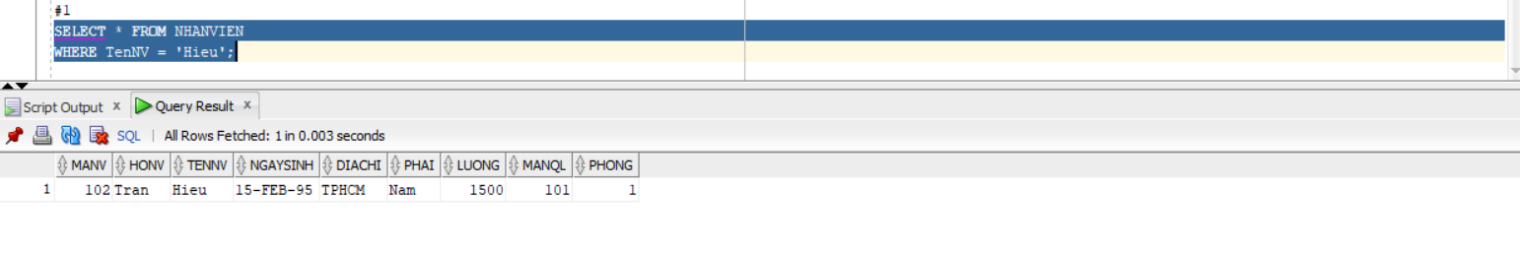
2.
SELECT nv.MaNV, nv.HoNV, nv.TenNV, nv.DiaChi
FROM NHANVIEN nv
JOIN PHONGBAN pb ON nv.Phong = pb.MaPhong
WHERE pb.TenPhong = 'Hanh Chinh';
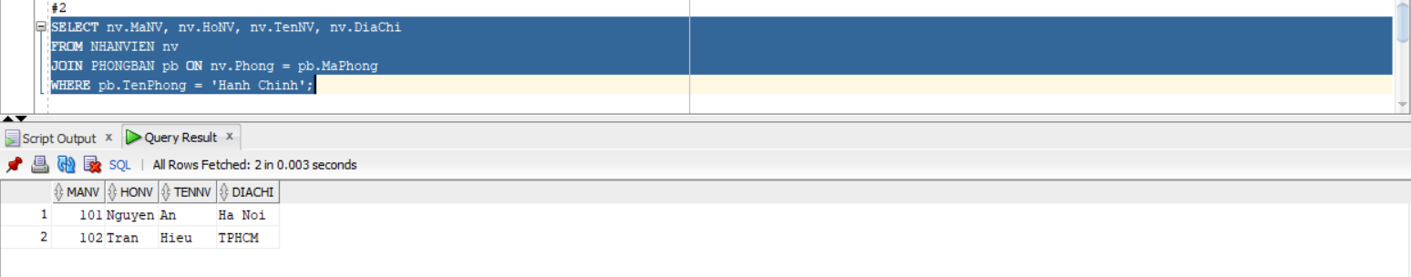
3.
SELECT nv.MaNV, nv.HoNV, nv.TenNV, nv.DiaChi
FROM NHANVIEN nv
JOIN PHONGBAN pb ON nv.Phong = pb.MaPhong
WHERE pb.TenPhong IN ('Hanh Chinh', 'Tai Vu');
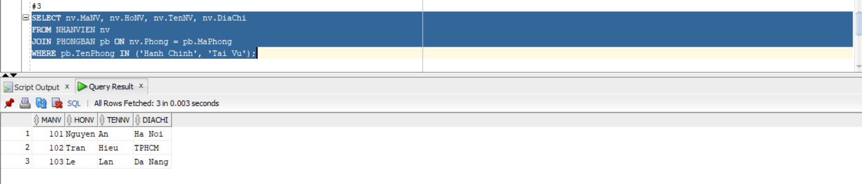
4.
SELECT nv.MaNV, nv.HoNV, nv.TenNV, da.TenDA
FROM NHANVIEN nv
JOIN PHANCONG pc ON nv.MaNV = pc.MaNV
JOIN DEAN da ON pc.MaDA = da.MaDA;
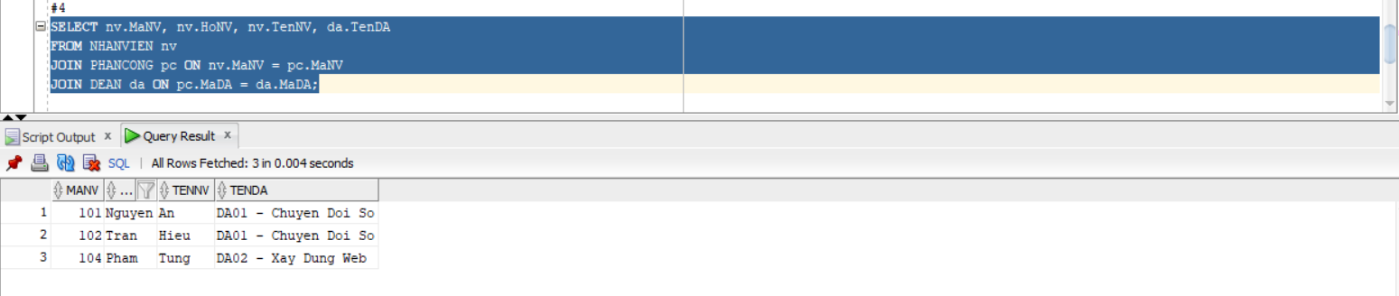
5.
SELECT da.MaDA, da.TenDA, pb.TenPhong, pb.TruongPhong AS MaTruongPhong, nv.TenNV AS TenTruongPhong
FROM DEAN da
JOIN PHONGBAN pb ON da.Phong = pb.MaPhong
JOIN NHANVIEN nv ON pb.TruongPhong = nv.MaNV;
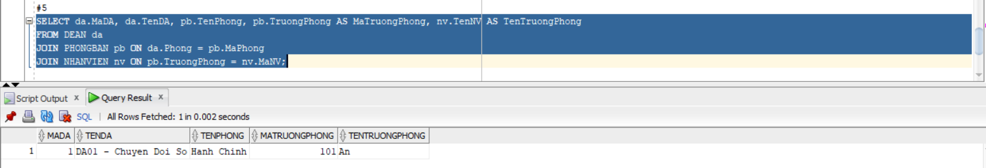
6.
SELECT nv.MaNV, nv.HoNV, nv.TenNV
FROM NHANVIEN nv
JOIN PHANCONG pc ON nv.MaNV = pc.MaNV
WHERE pc.MaDA = 1 AND pc.ThoiGian > 30;
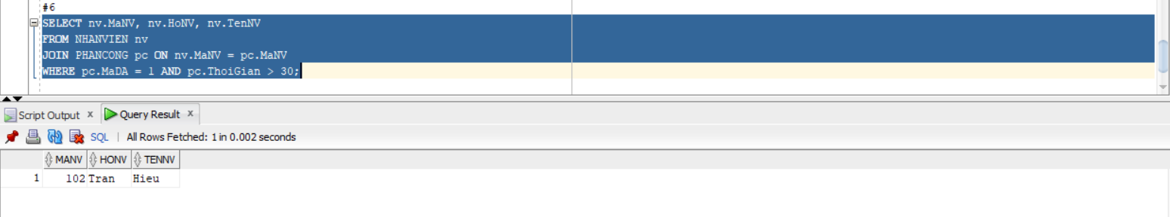
7.
SELECT nv.MaNV, nv.HoNV, nv.TenNV
FROM NHANVIEN nv
JOIN NVIEN_TNHAN nt ON nv.MaNV = nt.MaNV
JOIN THANHNHAN tn ON nt.MaTN = tn.MaTN
WHERE nv.TenNV = tn.TenTN;
